2 terrific technologies
V7
ClassPad (CAS) and Graphe Easy (software)
Presenter: Geoff Phillips
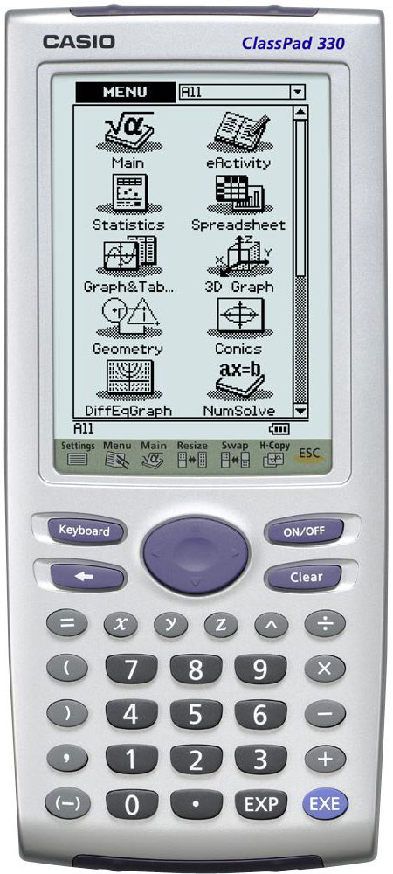
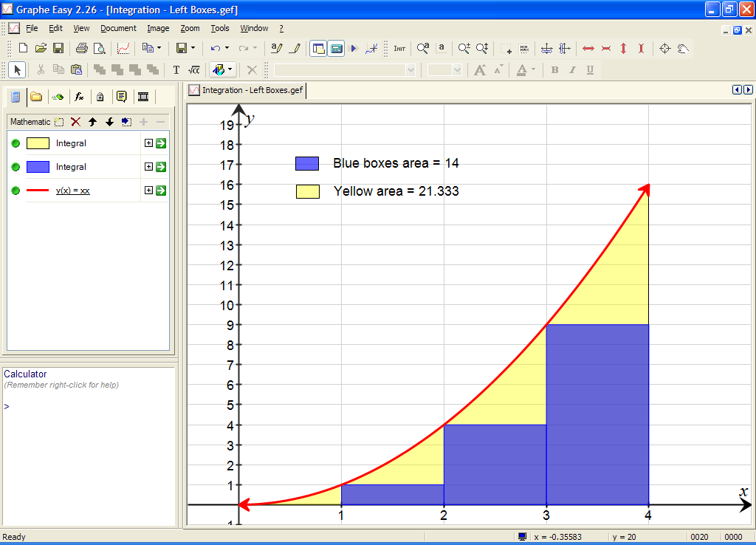

Session outline:

Part 1 ClassPad’s ease/speed of use − a tour of some highlights
Basic operation Modes (std/dec, rad/deg, recalc line/all)
Drag and drop (within and between apps), live updating
Keyboards 2D etc. simult. eqns, derivatives etc.
CAS alegebra solve, factorise, expand, differentiate, sim eqns etc.
Wizards e.g. Normal curve calcs.
Graphing p(x) = x3 + 5x2 −8x −12, locating key features, tangents and integrals, dynamic graph, panning.
Sequences Defining explicit/implicit, tables, sum, graphs
Solver Solve for any variable in an equation (no need to put = 0).
Main − Geom dragging from Main to Geometry app & vice verse.
Geometry unleashed incentre, theorems made fun, tangent animations, tables
Spreadsheet application copying data from Geometry area investigation
Statistics lists, stats calcs, regression calcs and plots.
eActivity family of functions, dragging to Main for analysis.
Questions How do I…..?

Part 2 Graphe Easy − teaching aid and desktop publishing application
Basic graphing y = xx
Built in features Plot types, Parameters, Integration, Data, DEs etc.
Teaching aid files Left boxes example, Gradient of secant.
Representing data Scatter, column and box plots.
Keyboard shortcuts Customising GE for use in desktop publishing.
Desktop publishing Formatting for tests and worksheets.
Part 1 ClassPad’s ease/speed of use − a tour of some highlights

Modes / keyboards

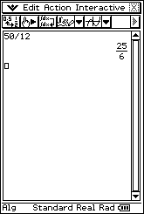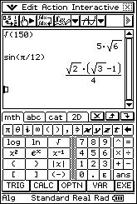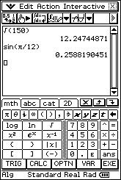

Drag and drop
Change top line (Define) Change one line only (line 3)
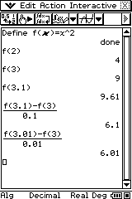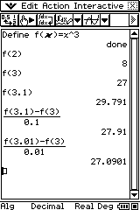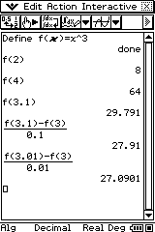

Simultaneous equations − 4 methods

“Command line” syntax. Matrix operation/2D keyboard 2D Template and drag to graph screen
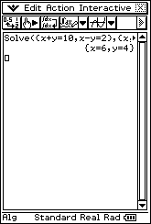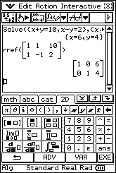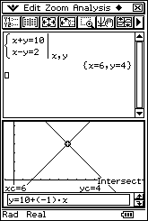

2D Keyboard

2D Keyboard. 2D Keyboard→CALC.
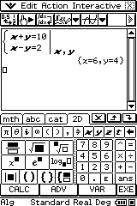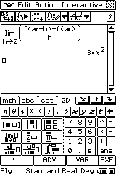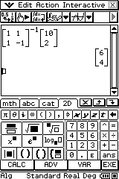

CAS algebra Wizards

Action or Interactive menu/ Interactive/Distribution/nornCDf
Transformation
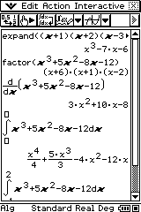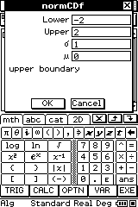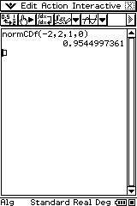

Graphing p(x) = x3 +5x2 − 8x −12

Graph icon, then Y=. Toolbar icon or Analysis/G−Solve/ Arrow key for next root.
Root.
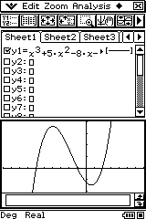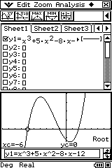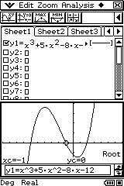

Toolbar icon or Analysis/G−Solve/ Tabulate icon. Points plot icon.
Max (Re−graph/click gr icon to clear dots)
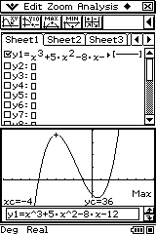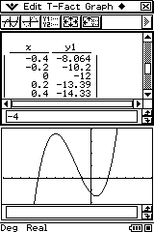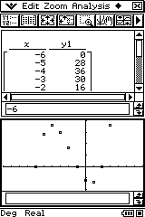

Analysis/Sketch/Tangent. Analysis/G−Solve/$\int{\text{dx}}$/Key lower Include a and b in equation.
◆ Dynamic Graph
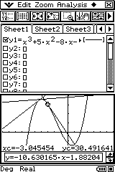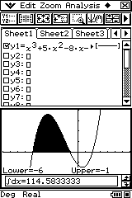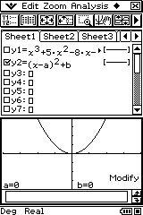

Main → Geometry

From Main, enter expression Create animation (Edit/Animate/Add) Drag table back to Geom window
Drag to Geometry window Edit/Animate/Go Once
Draw/Construct/Tangent to Curve Tabulate point co−ords and slope
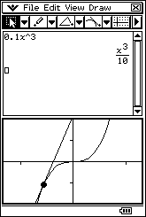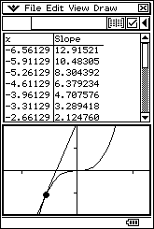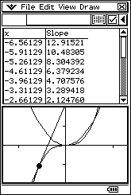

Solver / Financial app’s TVM solver

Menu→NumSolve Menu→Financial
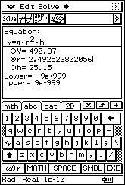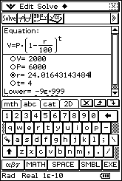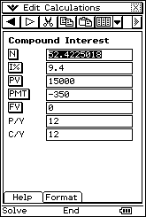

Sequences

Swimming pool problem Deer numbers Deer and cow nos − improved models
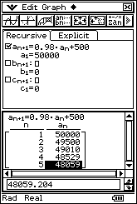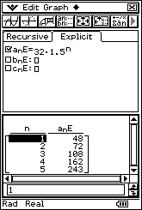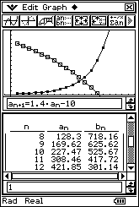

Geometry unleashed

Menu→Geometry Constraint based geometry Measurement/calculations
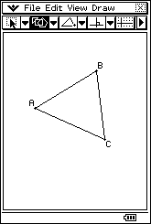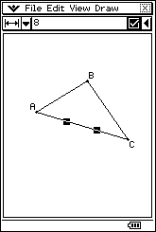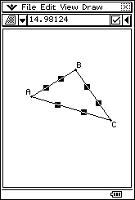

GP Geom/incentre Tap point, then touch again and drag Sine ratio (sinrat)
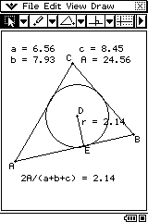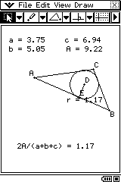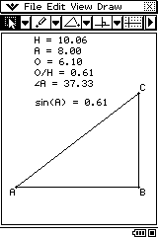

Spreadsheet application

Generating quadratics
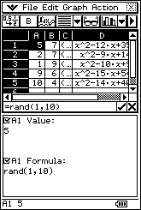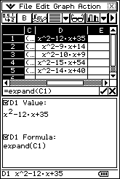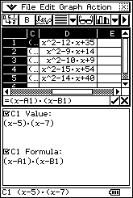

Combining applications (e.g. Geometry and Spreadsheet apps)

GP Geom/BlackAn Animate, Copy data. Paste to Spreadsheet, scatter graph.
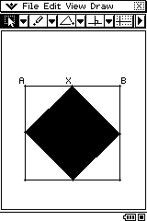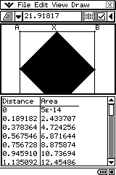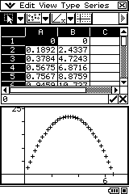

Statistics

SetGraph, setting 1,2,3. Tick StatGraph1. Calc, LinReg (list1, list2). Calc, Two−variable (list1,list2).
Tap graph icon.
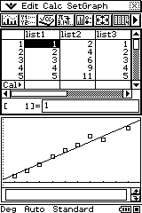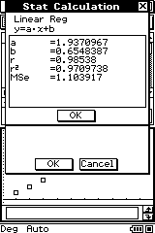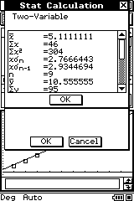

SetGraph, tick StatGraph2 only. SetGraph, tick StatGraph3 only. Calc, Distribution.
Tap graph icon. Tap graph icon. Select NormalCD in bottom box.
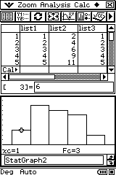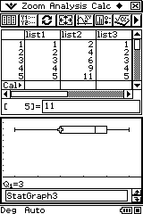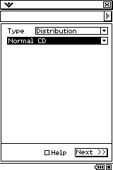

Enter Lower (−2) & Upper (2) values. Tap Next >> Tap graph icon in top toolbar.
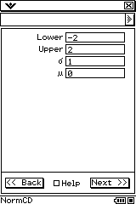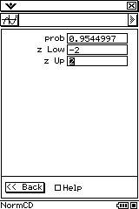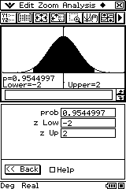

eAcitivities (i.e. Save−able files)

GPeActs/quad invn broch 1 What’s the pattern? Why do they all touch at one point?
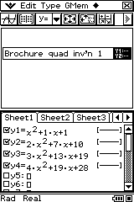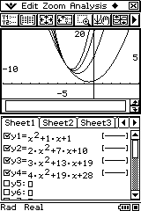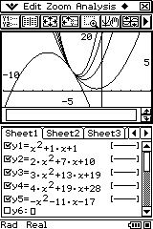

GPeActs/Triangle solver →sine rule →SOH
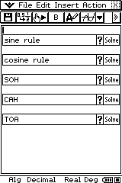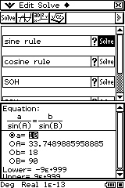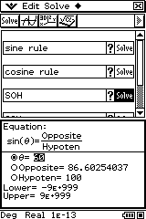

Questions − “How do I …?”

Part 2 Graphe Easy − teaching aid and desktop publishing application

Basic graphing y(x) = x2

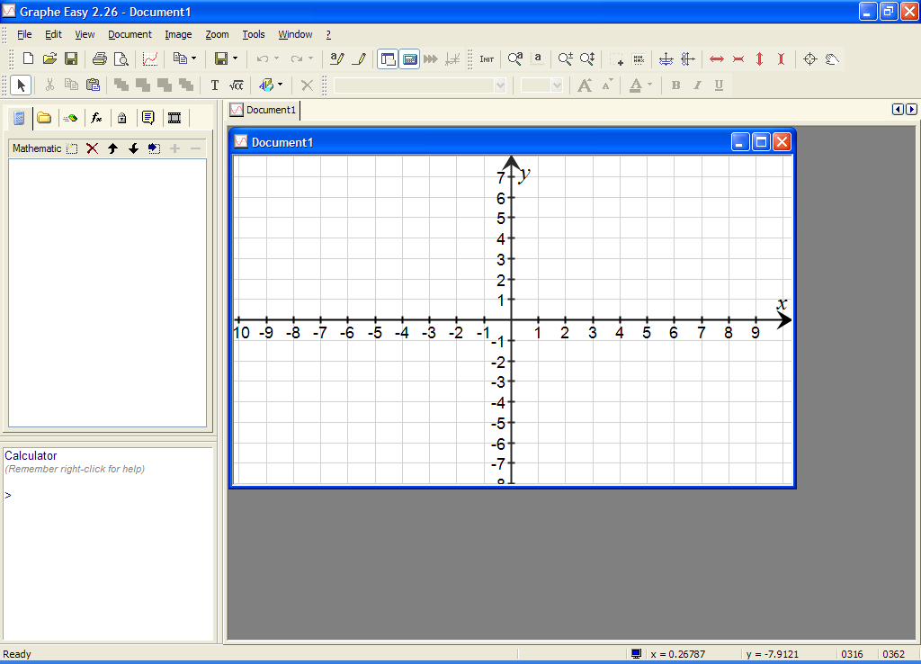

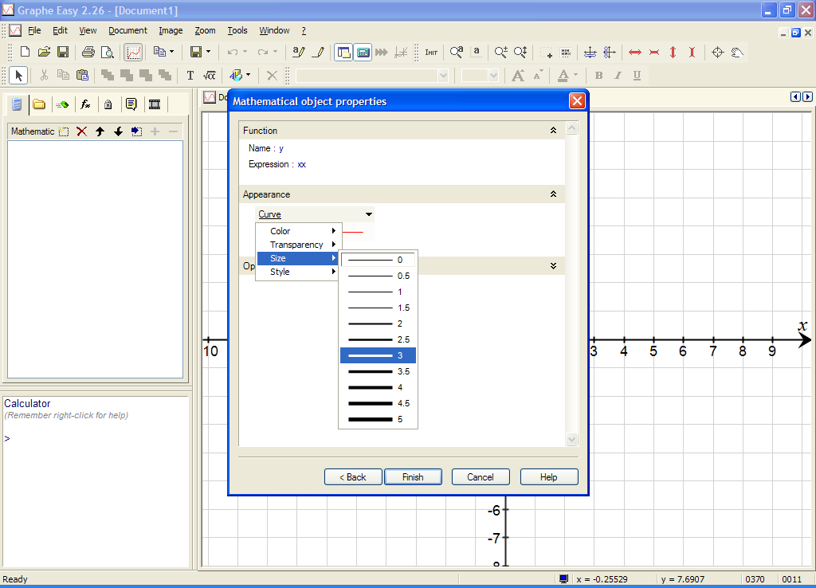
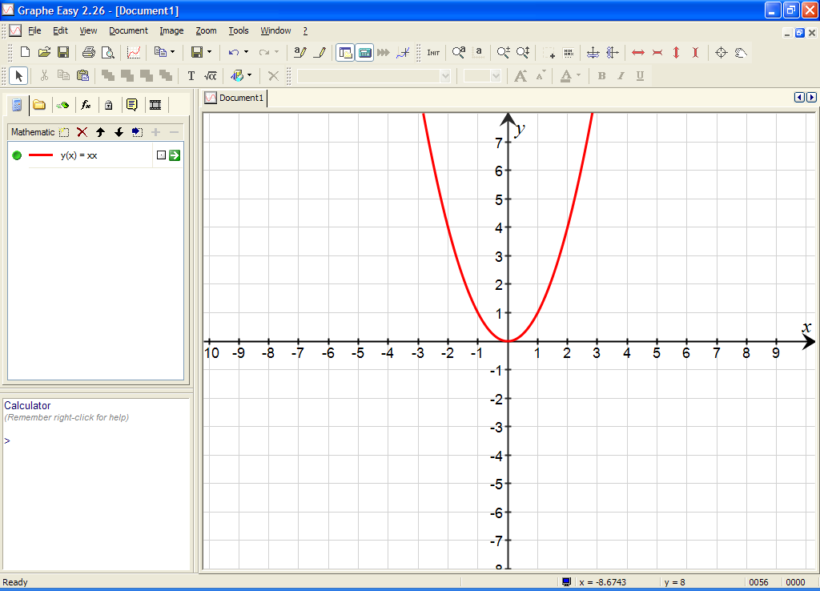

Built in features Parameters! Set up a, b and n.
Teaching aid file 1 Document→New Math Object→Integrals etc. Formatting.
Text Calc (* *) box & Commands.

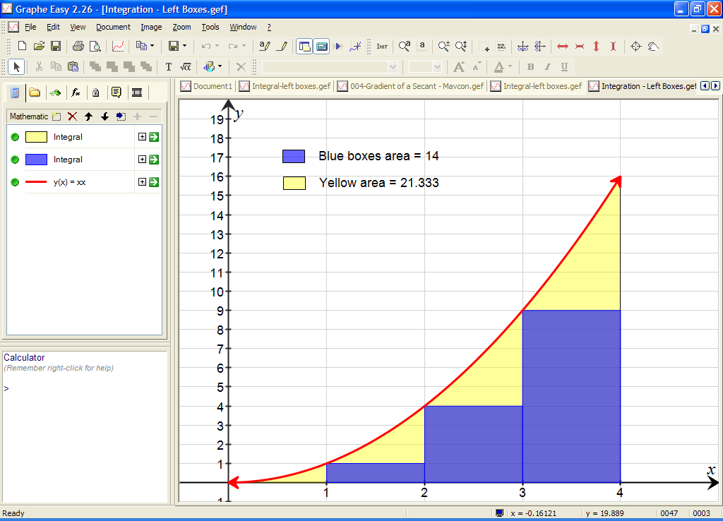
Teaching aid file 2 Introduction to limits, differential calculus

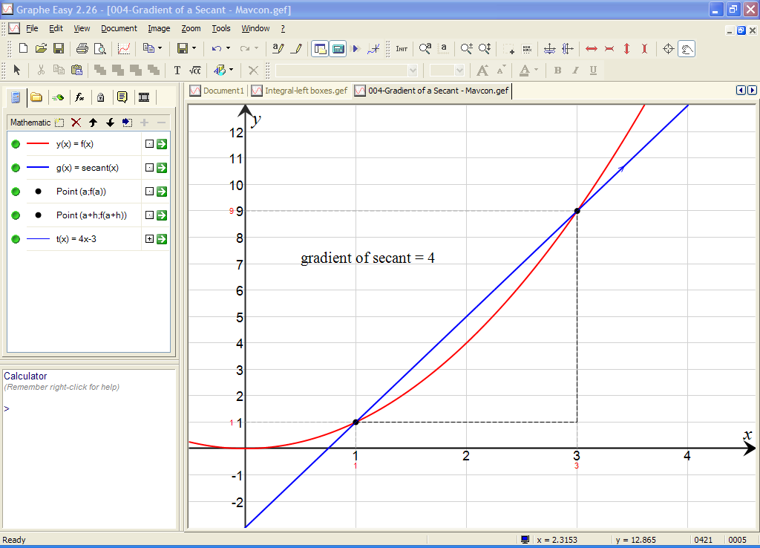

Teaching aid file 3 Differential equations and Euler’s method (screen 1)

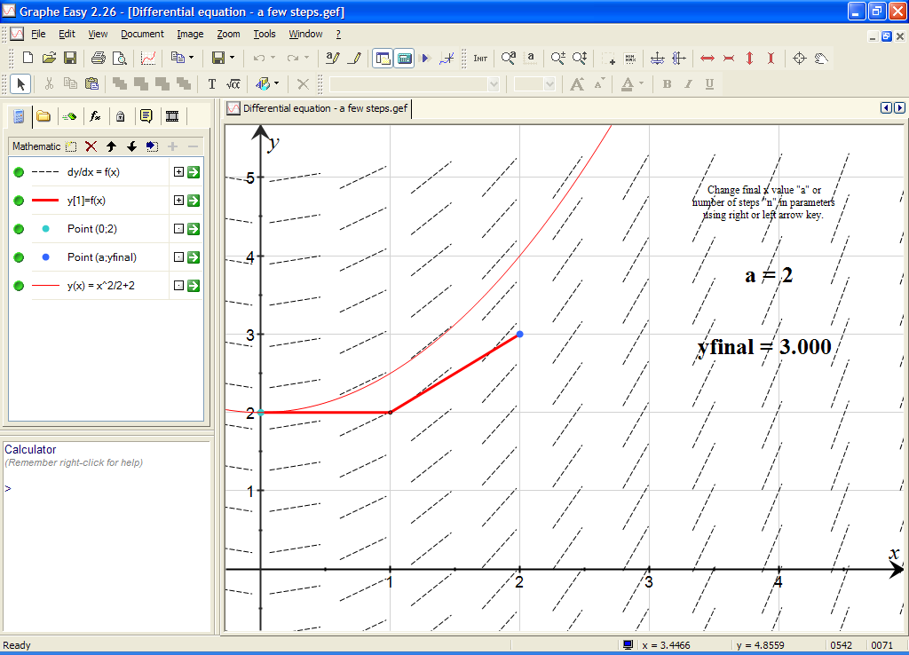

Teaching aid file 3 Differential equations and Euler’s method (screen 2)

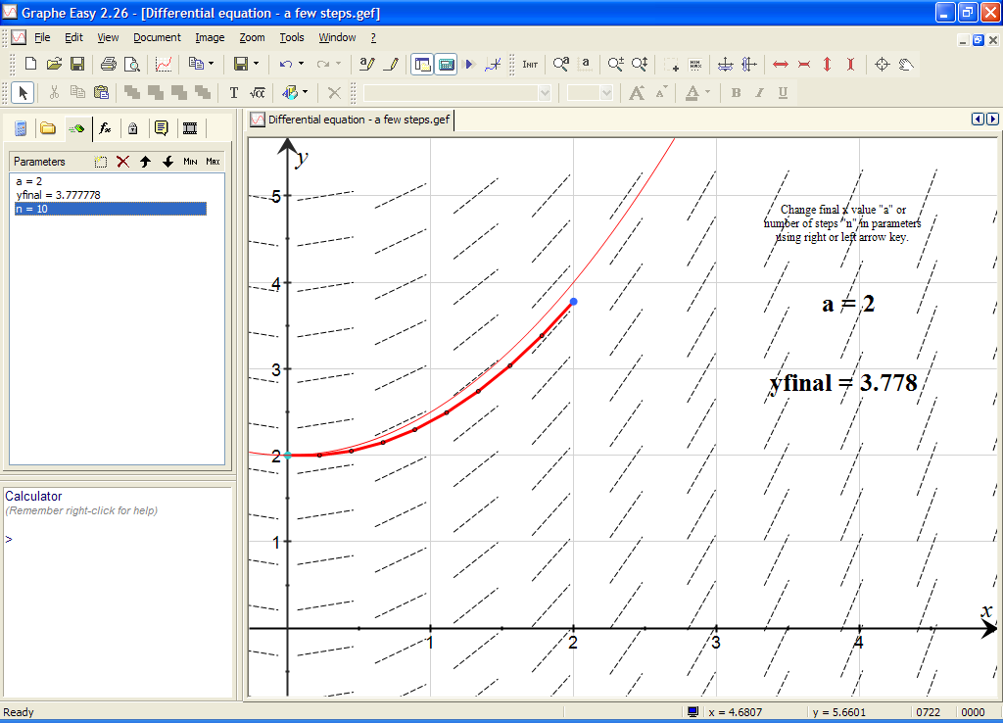

Representing data

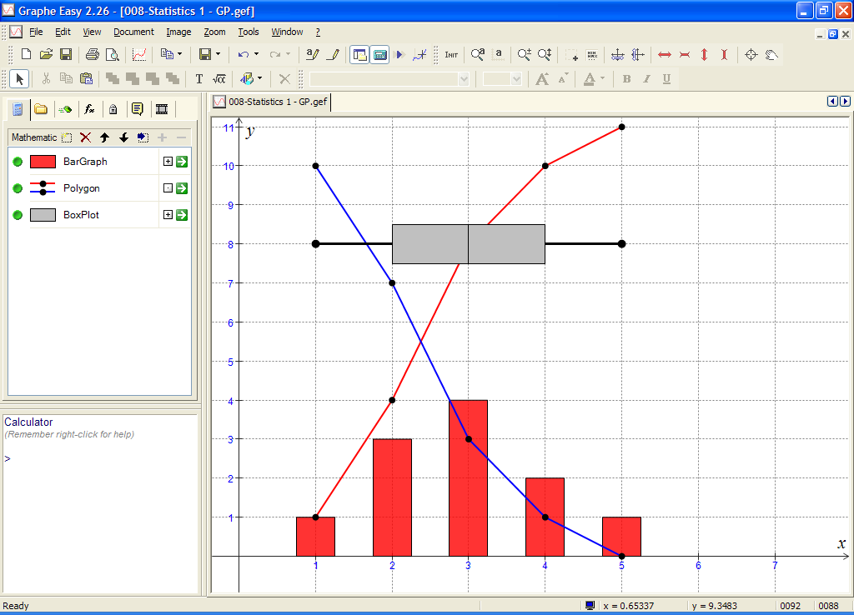

Keyboard shortcuts Tools→Customise→Keyboard

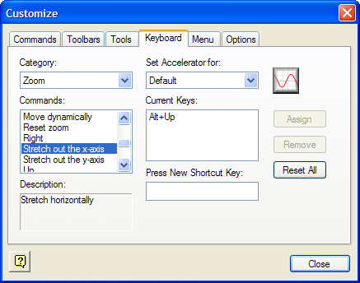

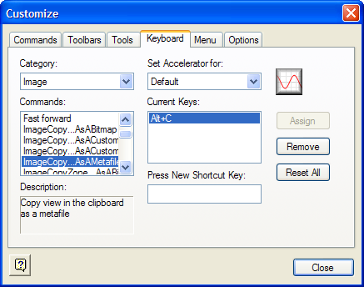

Formatting for tests and worksheets

Information and further resources

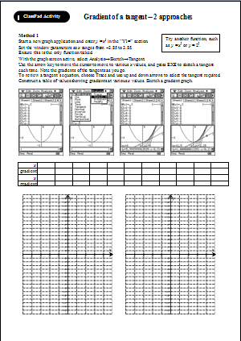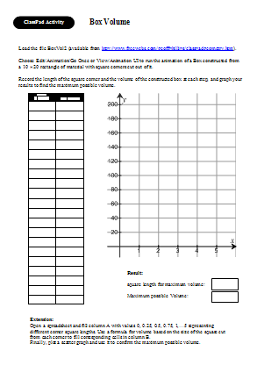

Site | Weblink/address
Geoff Phillips site | http://www.freewebs.com/geoffphillips
Geoff Phillips − ClassPad | http://www.freewebs.com/geoffphillips/classpad.htm
Geoff’s ClassPad pdfs | http://www.freewebs.com/geoffphillips/viewclasspadpdfs.htm
Geoff Phillips − Graphe Easy | http://www.freewebs.com/geoffphillips/grapheeasy.htm
CasioEd ClassPad support | http://www.casioed.net.au/products/classpad_product.php
Graphe Easy Homepage | http://www.grapheeasy.com
Geoff’s email address | gphillips@bigpond.com
ClassPad support | casio.edusupport@shriro.com.au
Geometry theorems | http://agutie.homestead.com/files/index.html

Appendix ClassPad Geometry and calculus − The gradient function eActivity

eActivity/Gradient function GP Tap icon and maximise window Notice level tangent (zero gradient).
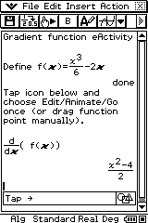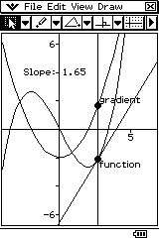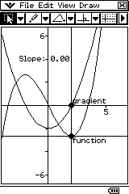

eActivity/More theorems/Circle tangents →Cevians and areas →Van Aubel’s theorem
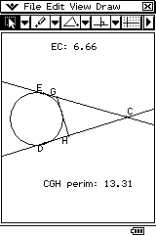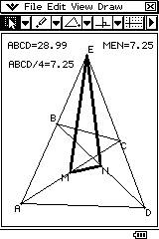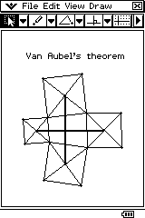

Geometry→GP_Geom/BoxVol2 Geometry→GP_Geom→GradChor GPeActs→Grad−tangt•
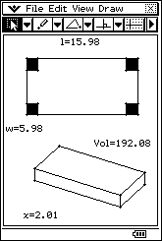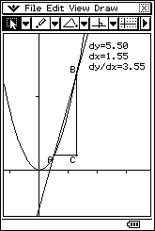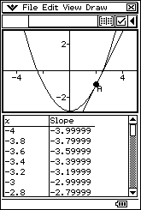

GPeActs→Integral anim GPeActs→River and fence 2 (Geom) GPeActs→ River and fence 2 (SS)
